Instructions for Re-Mapping GE

In order to align SUNY Delhi programs with the new SUNY General Education (GE) requirements framework, each program must submit a General Education Program Changes Form to Curriculum Committee. This should be relatively simple.
- In the left columns of the table, provide your current GE requirements per semester (course #, name, and GE designation)
- In the right columns, provide your new proposed GE requirements per semester (course #, name, and GE designation)
  - Your new GE requirements may map very closely to the old. In this case, feel free to use the crosswalk below to determine the changes.
  - Alternatively, you may choose to require different GEs or need to make room for the DEI GE. Simply place these new courses to the right of whichever GE you are consequently removing.
  - The new GE designations are provided in the table below.
- Changes beyond these GE substitutions must still be submitted via a Program Change form.

GE Resources

New & Old GE Crosswalk
* indicates a required GE for all undergraduate programs

Old GE Designation | Old GE | New GE Designation | New GE
1 | Mathematics* | MATH | Mathematics (and Quant Reasoning) *
2 | Natural Sciences* | NSCI | Natural Sciences (and Sci Reasoning) *
3 | Social Sciences | SOCS | Social Sciences
4 | American History * | USCV | US History & Civic Engagement
5 | Western Civilization | GLBL | World History & Global Awareness
6 | Other World Civilizations
7 | Humanities | HUMN | Humanities
8 | The Arts | ARTS | The Arts
9 | Foreign Language | WLNG | World Languages
10 | Basic Communication* | COMW & COMO | Communication: Written & Oral*~
 |  | DVRS | Diversity: Equity, Inclusion, and Social Justice*
Competency | Critical Thinking* | RESN | Critical Thinking & Reasoning*+
Competency | Information Literacy* | INFO | Information Literacy*^

~ As in our current framework, the Oral and Written components of the Communication GE will be covered in separate classes: Public Speaking, Business Communication, or Argumentation & Debate and one of our ENGL courses (ENGL 100, 200, 250).
+The critical competence of Critical Thinking & Reasoning will be embedded and assessed in Natural Sciences.
^The critical competence of Information Literacy will be embedded and assessed in Communication: Written.

Required GE per program

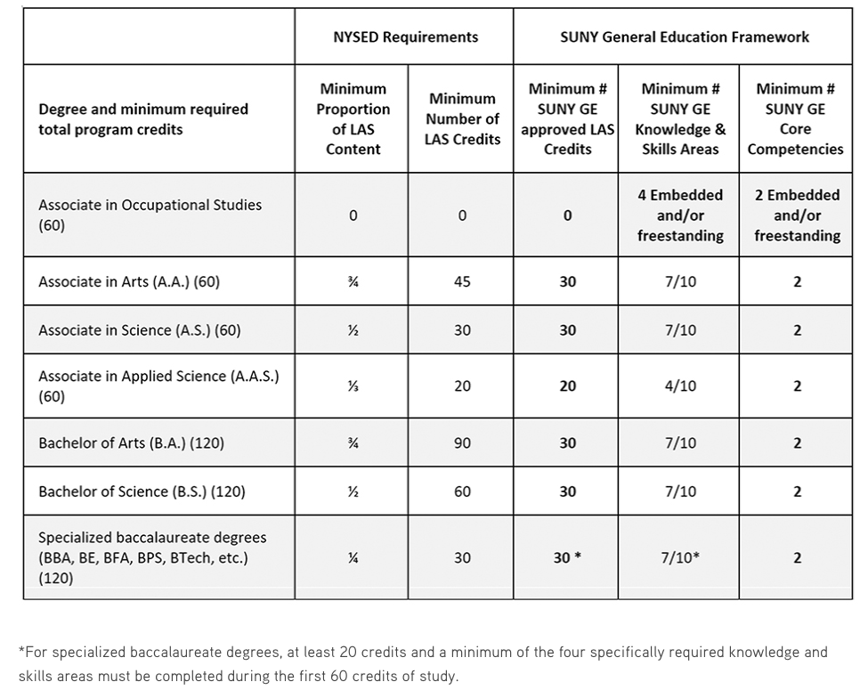

SUNY Webpages

SUNY General Education SLOs and information
A breakdown of GE SLOs

SUNY General Education Credit & Category Requirements
A breakdown of GE credit earned and categories required per degree type

SUNY General Education Framework
An extensive breakdown of GE requirements, guiding principles, procedure, and FAQ

