
OFFICE of RESIDENCE LIFE
TEL: 607 746-4630
FAX: 607 746-4086
EMAIL: ResLife@delhi.edu
WEB: www.delhi.edu

Off-Campus Accommodations
Updated: 07/24/2017

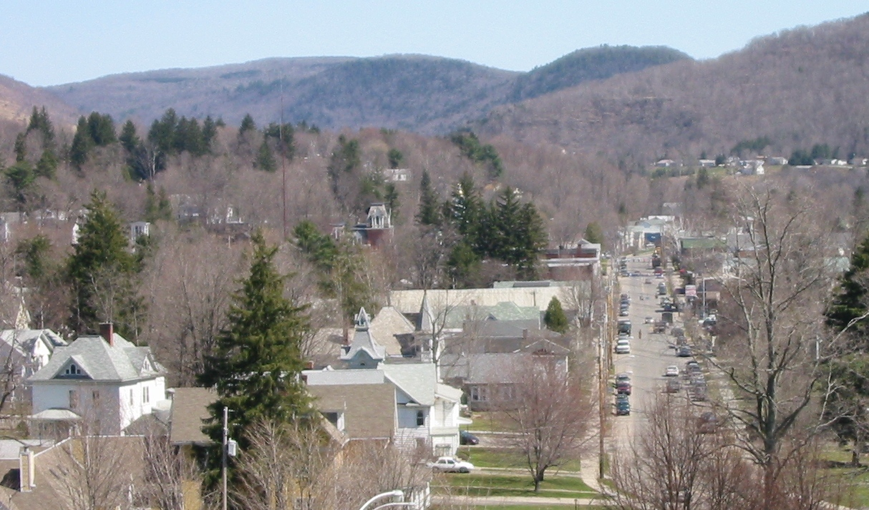
Reminder: Students living on campus during Fall 2016 have signed a contract for the full tained written permission from the Office of Residence Life, 111 Catskill Hall.

academic year and are not free to move off-campus for Spring 2017 unless they have ob

A current copy of this document can be found on our website at: http://www.delhi.edu/campus_life/housing/index.php
OFFICE of RESIDENCE LIFE
TEL: 607 746-4630
FAX: 607 746-4086
EMAIL: ResLife@delhi.edu
WEB: www.delhi.edu

POLICY OF NON-DISCRIMINATION IN HOUSING

The State University College of Technology at Delhi affirms support of the New York State Human Rights Law regarding housing, which states:

It shall be an unlawful discriminatory practice for the owner, lessee, sub-lessee, assignee, or managing agent of publicly-assisted housing accommodations or other person having the right of ownership or possession of or the right to rent or lease such accommodations:
(a) To refuse to sell, rent or lease or otherwise to deny to or withhold from any person or group of persons such housing accommodations because of the race, creed, color, disability, national origin, sexual orientation, military status, age, sex, marital status, or familial status of such person or persons, or to represent that any housing accommodation or land is not available for inspection, sale, rental or lease when in fact it is so available.
http://www.dhr.state.ny.us/law_and_regulations_unlawful_discriminatory.html

If owners or their families are living in the two-family house or a house where rooms are to be rented, they are exempt from the law.

The Village of Delhi’s code website http://www.ecode360.com/?custId=DE0305, specifically Chapter 228, discusses rental requirements for Village properties.

NOTICE TO STUDENTS

All full-time undergraduate students must live in SUNY Delhi residence facilities; students who meet the following exceptions are not required to reside in SUNY Delhi residence facilities:
- married students
- students living with parents or guardians and commuting (within a 50 mile radius)
- students 21 years of age or older, prior to October 1 of the academic year in which they enroll (prior to March 1 for those enrolling for the spring semester)
- Other requests will be considered on a case by case basis

In order to request permission to live off-campus, students must complete the online Request to Live Off Campus form located at http://www.delhi.edu/campus_life/housing/form_liveoffcampus.php. Please realize that requesting permission is not the same as receiving permission. Once you submit your request, you will immediately receive an email to your Delhi email address confirming we have received your request to live off campus. Within three business days you will receive an email from the Office of Residence Life letting you know if your request to live off campus has been approved or not.
 

This listing is maintained as a service for your convenience. University employees do not inspect, approve or supervise the premises described, and the University does not become a party to private landlord-tenant or landlord-prospective tenant matters. Information regarding the premises has been provided by the landlord and the University makes no guarantee to its veracity by inclusion of the premises on this list. You are encouraged to learn and understand all of your rights, responsibilities and protections afforded under the law before signing any rental agreement.

The New York State Attorney General’s Office provides a “Tenants’ Rights Guide” online at http://www.ag.ny.gov/sites/default/files/pdfs/publications/Tenant_Rights_2011.pdf that may be of assistance to you. In addition, the Delhi Code Enforcement Officer may be reached at 607-746-2622 or codeofficer@delhitel.net.

It is our suggestion that you make sure that you understand everything clearly about a rental property before you make any commitments. It is a good idea to speak with someone that has rented from the person(s) previously so you can better understand what to expect.

If you are relying on financial aid to cover expenses, please be sure to speak with someone in the Office of Financial Aid at 607-746-4570 to clarify the manner in which financial aid would cover housing expenses.
 

We urge you to remember in your dealings with the surrounding community, that you are a reflection of SUNY Delhi students and we hope your actions will represent the general student population well. We would also like to remind you that a positive reference from a landlord would be an asset to you in the future.

For additional listings, you might also try the following on-line newspaper classified ads:
http://www.countyshopper.pennysaverusa.com/ (Delaware County)
http://www.thedailystar.com (Oneonta newspaper, online version)

Good luck in your search for off-campus housing, but remember that making arrangements earlier will give you a better selection. If you have any questions, comments or concerns regarding this off-campus listing, please feel free to contact the Office of Residence Life at 607-746-4630 or reslife@delhi.edu.
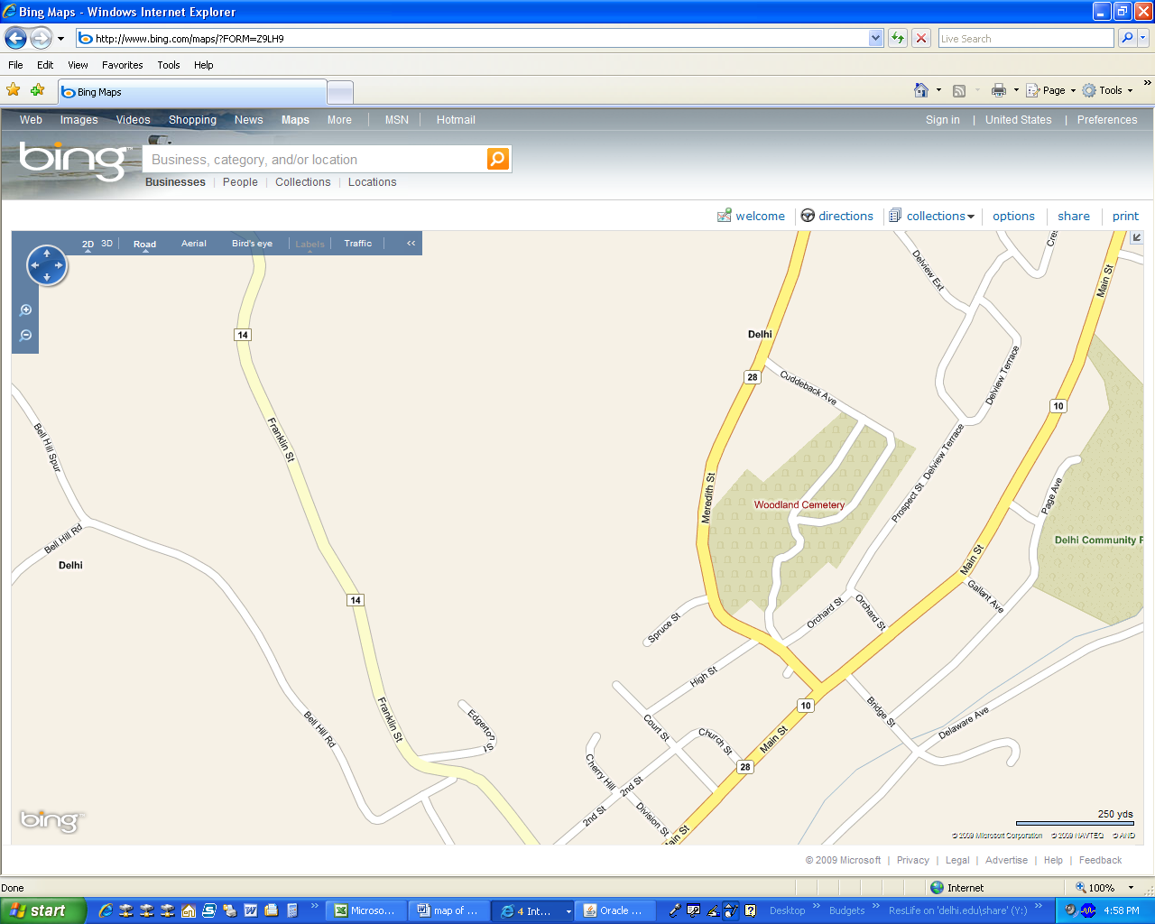
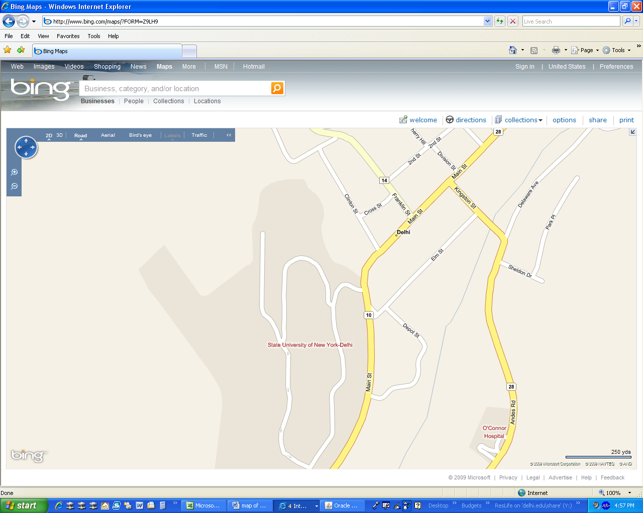
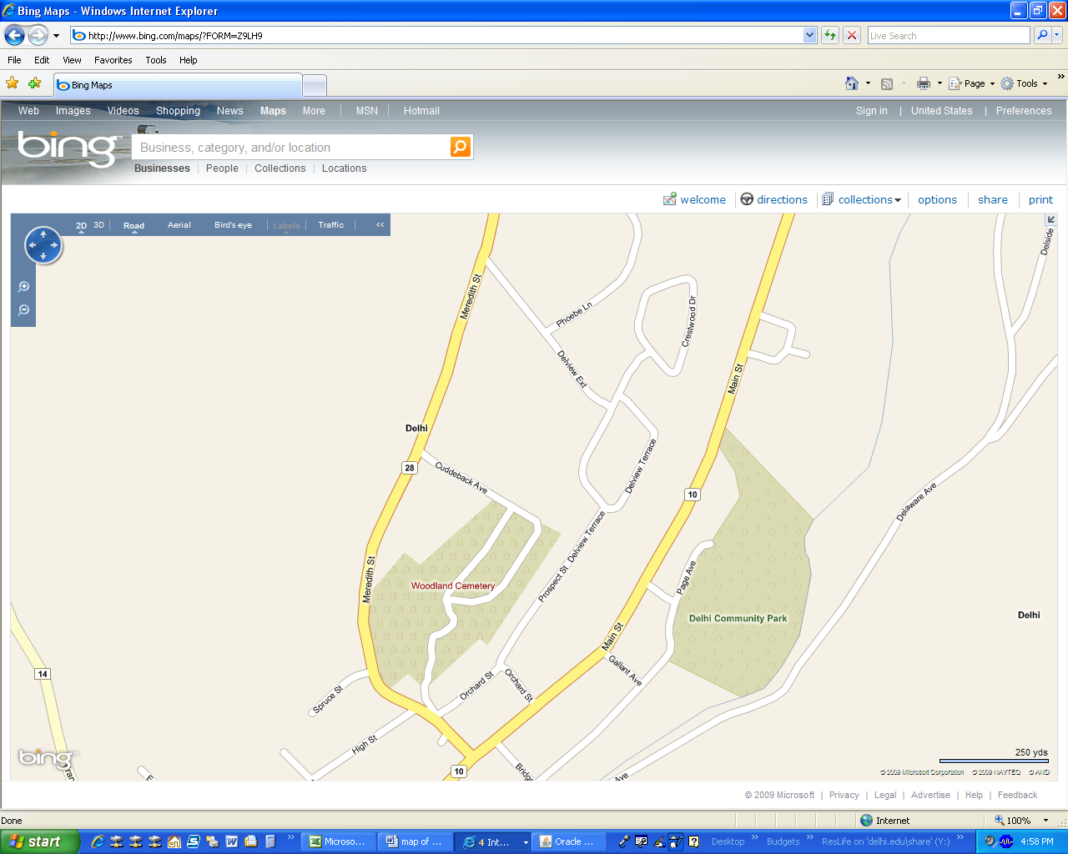
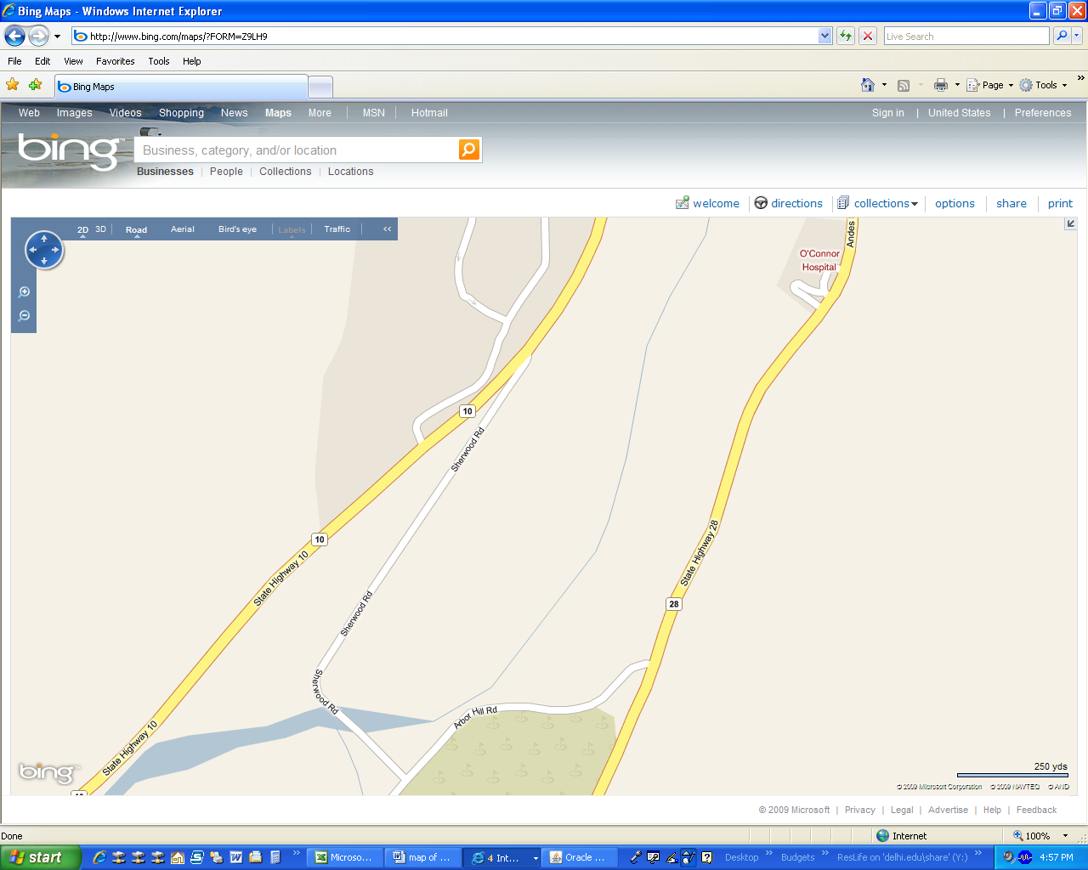

7/24/2016
Male or Female. Location: 18 Court St, less than ½ mile from campus. Rent: $2,700 and $2,400/semester (plus electric) Required: Semester lease and $600 returnable security deposit. Listing Info: Two-bedroom apartment. Top floor. Private, attractive, quiet, kitchen, bath. Rent includes water, heat, garbage removal, off-street parking. Restrictions: No smoking. No Fraternities or Sororities. No pets unless with approval. Contact Info: Stewart Schwartz , Pomona, NY 10970 Tel: 845-354-1122 Email: stewspeak@aol.com Inspected by Village of Delhi Code Officer

7/24/2016
Male or Female. Location: 18 Court St, less than ½ mile from campus. Rent: $2,700 and $2,400/semester (plus electric) Required: Semester lease and $600 returnable security deposit. Listing Info: Two-bedroom apartment. First floor. Private, attractive, quiet, kitchen, bath. Rent includes water, heat, garbage removal, off-street parking. Restrictions: No smoking. No Fraternities or Sororities. No pets unless with written approval. Contact Info: Stewart Schwartz , Pomona, NY 10970 Tel: 845-354-1122 Email: stewspeak@aol.com Inspected by Village of Delhi Code Officer

7/24/2016
Male or Female. Location: 18 Court St, less than ½ mile from campus. Rent: $2,700, $2,500, & $2,400 /semester (plus electric) Required: Semester lease and $600 returnable security deposit Listing Info: Large THREE-bedroom apartment, Private, attractive, quiet, . Rent includes water, heat, garbage removal, off-street parking. Restrictions: No smoking. No alcohol parties. No pets. No fraternities or sororities. Contact Info: Stewart Schwartz, Pomona, NY 10970 Tel: 845-354-1122 Email: stewspeak@aol.com Inspected by Village of Delhi Code Officer

7/24/2016
Male or Female. Location: 185 Main Street. Half mile from Campus. Rent: $2,750 per student per semester for single bedrooms; $2,250 if sharing huge double bedroom. Required: semester lease and $500 security deposit. Listing Info: 3 bedroom apartment. Private entrance, bath room, large kitchen including breakfast bar and refrigerator, large living room with dinning table. All bedrooms have bed, walk in closet, work desk. Rent includes water, electric, heat, wi-fi, garbage removal, off-street parking. Features include separate enclosed gallery with mountain views, large yard, and storage space avail. Restrictions: No pets. Overnight guests/parties by arrangement. Contact Info: William Thompson. 185 Main street, Delhi, NY 13754. Tel: 607-464-4038. Email: wthompson003@stny.rr.com. Inspected by Village of Delhi Code Officer.

7/19/2016
Male or Female. Location: 56 Sherwood Drive Rent: $3,500 per student per semester OR 5,000 for two students Required: semester lease and $500 security deposit OR $600 security deposit for 2 students Listing Info: 1 bedroom house/apartment. Private entrance, bath, kitchen (including refrigerator) and laundry shared with family. Rent includes water, electric, heat, internet, garbage removal, off-street parking. Restrictions: No smoking, parties or overnight guests. Contact Info: Daniel R. Kennedy, 56 Sherwood Drive, Delhi, NY 13753 Tel: 607-434-4775 or 607-746-8250

7/10/2016
Male or Female. Location: 18-20 Orchard St, 1.2 miles from campus Rent: $3,200 perstudent per semester Required: semester lease and $300 security deposit Listing Info: 8 rooms available in house shared with other students. Shared entrance, bath, kitchen (including refrigerator) laundry. Rent includes water, electric, heat, internet, garbage removal, snow removal, off-street parking. Restrictions: No smoking, alcohol, pets, parties or overnight guests. Contact Info: Jill Ogden, 4 Spruce St, Delhi, NY 13753 Tel: 607-267-0313 Email: jillaogden@gmail.com

7/10/2016
Female. Location: 31 Main St, diagonally across from campus Rent: $3,000 per semester. Required: signed lease, $500 security deposit Listing Info: 3-bedrm apt. with private entrance includes bathroom, kitchen (with refrigerator, and gas stove/oven), common dining space & living rm. Rent includes internet, furnishings (bed, bureau, desk, living/dining furniture), water, electric, heat, garbage removal, snow removal, off-street parking. Restrictions: No smoking, pets or parties. Contact Info: Lou Marrelli Tel: 917-804-7190
Email: loumarrelli@yahoo.com.
Notes: One female to share 3 bdrm apt with two other females Inspected by Village of Delhi Code Officer.

06/30/2017
Male or Female. Location: 64 Meredith Street, 1 mile from campus Rent: $2,600 per student / per semester Required: 2-semester lease and $400 security deposit Listing Info: 2 bedrooms available in a 4 bedroom furnished house, shared with owner and other students. Full bathroom upstairs and a ½ bathroom downstairs. Kitchen priviledges. Laundry room available. Private, quiet neighborhood. Rent includes water, heat, wireless internet, garbage removal and off-street parking. Restrictions: No smoking, pets or parties Contact Info: Patricia Bower Tel: 607-376-3105 Email: patricia.bower.44@gmail.com Inspected by Village of Delhi Code Officer.

06/30/2017
Male or Female. Location: 21529 State Highway 28, 4 miles from campus Rent: $2,700 per student/semester Required: 2 semester lease and $500 security deposit Listing Info: 2-bedrm house shared with family available on working dairy farm with onsite creamery specializing in artisanal cheeses offering hands on experience. Entrance, bath, kitchen, and refrigerator shared with other students. Rent includes water, heat, electric, snow removal, garbage removal and off-street parking. Restrictions: No smoking, alcohol, parties or overnight guests. Preference is for Vet Tech students and Culinary students with a serious interest in Farm to Table. Pets ok on approval. Contact Info: Aissa O’Neil, 21529 State Highway 28 Delhi NY 13753 Tel: 607-746-9581 Website: www.bettyacresfarm.com Email: Aissa348@gmail.com

06/26/2017
Male or Female. Location: 84 Main Street, ¼ mile from campus Rent: $2,850 per semester, per student Required: 2-semester lease Listing Info: : 2 rooms available in apartment shared with other students. Rent includes water, internet, heat, garbage removal, snow removal, off-street parking. Contact Info: Tom Jefferys, 1807 Federal Hill Road #1, Delhi. Ny 13753 Tel: 607-434-0739 Email: t_jefferys@yahoo.com

06/19/2017
Male or Female. Location: 3 Cherry Hill, ¼ mile from campus Rent: $2,800 per student/semester Required: $250 security deposit Listing Info: 3 fully-furnished large private suites available in spacious Victorian house shared with owner. Shared entrance, kitchen (including refrigerator), laundry, private bath. Sunny patio & porches, yard, storage space avail.Rent includes water, electric, heat, cable TV, internet, garbage removal, off-street parking. Restrictions: No smoking or alcohol. Contact Info: Norman & Janet Erickson , 3 Cherry Hill, Delhi, NY 13753 Tel: 607-437-6805 or 607-441-7022 Email: janetlouise@att.net Note: Peaceful environment conducive to study. 5-10 minute walk to campus.

06/12/2017
Male or Female. Location: 32 Elm Street, ¾ mile from campus Rent: $1,900 per semester Listing Info: : Room available in home shared with owner. Rent includes water, electric, heat, garbage removal, snow removal, off-street parking. Restrictions: No smoking, alcohol, pets, parties, or overnight guests Contact Info: Joan Townsend, 32 Elm Street, Delhi, NY 13753 Tel: 607-746-8417 Email: joantownsend4970@gmail.com

06/08/2017
Female. Location: 10 Elm St, >1 miles from campus Rent: $3,000 per student/semester Required: 2-semester lease and $750 security deposit Listing Info: 1 bedrms available in 4 bdrm house shared with other students. Entrance, bathroom, and kitchen (including refrigerator) shared with other students. Rent includes water, electric, heat, garbage removal, snow removal, off-street parking. Contact Info: Dillon Nash, 170 Old Country Rd, #310, Mineola, NY 11501 Tel: 516-474-1278 Email: info@offcampusdelhi.com
Note: 3 Female Students Seeking a 4th Female. 4 bedroom / 1 bathroom home located across the street from campus. Brand new kitchen and recent updates throughout the home

06/07/2017
Male or Female. Location: 40 Main Street, ¼ mile from campus Rent: $2,500 per student/semester (plus electric) Listing Info: 2-bedrm apt; private entrance. Rent includes water, heat, garbage removal, snow removal, off-street parking. Contact Info: David Douglin , 35 Main St., Delhi, NY 13753 Tel: 607-865-9477 Email: ddouglin@frontiernet.net

06/07/2017
Male or Female. Location: 153 Main Street, ½ mile from campus Rent: $2,500 per student/semester Listing Info: 3-bedrm apt; private entrance. Rent includes water, heat, garbage removal, snow removal, off-street parking. Contact Info: David Douglin , 35 Main St., Delhi, NY 13753 Tel: 607-865-9477 Email: ddouglin@frontiernet.net

06/05/2017
Male or Female. Location: 30 Meredith St, ½ mile from campus Rent: $3,000 per student/semester Required: 2 semester lease and $300 security deposit Listing Info: 2 rooms available in house shared with other students; shared entrance, bath, kitchen (including refrigerator), laundry. Rent includes water, electric, heat, garbage removal, off-street parking. Restrictions: No alcohol, pets, parties or guests Contact Info: Charles Favorito , 229 Hawthorne Ave, Staten Island, NY 10314 Tel: 718-614-1861 or 917-273-9120 Email: donna39080@aol.com

05/22/2017
Male or Female. Location: 3 Division St., ¼ mile from campus Rent: $2,800 per student/semester Required: $600 security deposit Listing Info: 1 bedrm in a 2-bedrm apt; private entrance. Rent includes water, electric, heat, garbage removal, snow removal, off-street parking. Contact Info: Michael Kudrewicz, 3664 Cty Hwy 18, Delhi, NY 13753 Tel: 607-435-1395 Email: joannkdz@gmail.com Inspected by Village of Delhi Code Officer.

05/22/2017
Male or Female. Location: 3 Division St., ¼ mile from campus Rent: $2,800 per student/semester Required: $600 security deposit Listing Info: 1 bedrm in a 3-bedrm apt; private entrance. Rent includes water, electric, heat, garbage removal, snow removal, off-street parking. Contact Info: Michael Kudrewicz, 3664 Cty Hwy 18, Delhi, NY 13753 Tel: 607-435-1395 Email: joannkdz@gmail.com Inspected by Village of Delhi Code Officer.

05/22/2017
Male or Female. Location: 3 Division St., ¼ mile from campus Rent: $3,500 per student/semester Required: $600 security deposit Listing Info: 1-bedrm apt; private entrance. Rent includes water, electric, heat, garbage removal, snow removal, off-street parking. Contact Info: Michael Kudrewicz, 3664 Cty Hwy 18, Delhi, NY 13753 Tel: 607-435-1395 Email: joannkdz@gmail.com Inspected by Village of Delhi Code Officer.

05/17/2016
Male or Female. Location: 156 Main St, ½ mile from campus Rent: $3,100 per student/semester Required: Academic year lease and $500 security deposit Listing Info: 3-bedroom apartment, looking for 3 students. Private entrance, semi-furnished, full kitchen with appliances (gas stove), eating area, living room, one bathroom. All bedrooms are spacious with closets. Rent includes water, electric, heat, cable, garbage removal and snow removal and off-street parking. Restrictions: No smoking, pets or parties Contact Info: Richard Maxey Tel: 607-746-6201 Note: All serious students. Inspected by Village of Delhi Code Officer.

05/15/2016
Male or Female. Location: 3 Woolerton Street, ½ mile from campus Rent: $1,600 per student/semester Required: $100 security deposit Listing Info: 1 clean, quiet rooms left out of 4 on 2nd floor available in house shared with owner. Entrance shared with family; bath, refrigerator, microwave, toaster shared with other students. Rent includes water, electric, heat, cable TV, internet, garbage removal and snow removal. Restrictions: No smoking, alcohol, pets or parties Contact Info: Carol Little , 3 Woolerton St., Delhi, NY 13753 Tel: 607-746-2005 Email: carolkl@dmcom.net

05/09/2017
Male. Location: 152B Main Street, ½ mile from campus Rent: $2,950 per student/semester Required: academic year lease and $500 security deposit Listing Info: 3-bedrm apt, nicely furnished, extra clean. Private entrance, bath, kitchen (incl. refrigerator). Rent includes water, electric, heat, garbage removal, off-street parking. Restrictions: No smoking, pets, underage drinking or parties. Contact Info: Leslie Mignier, 374 Dick Mason Rd, Delhi, NY 13753 Tel: 607-746-7487 or 607-746-2248 (leave message) Note: House with all serious students. Inspected by Village of Delhi Code Officer.

05/09/2017
Male. Location: 152A Main Street, ½ mile from campus Rent: $3,250 per student/semester Required: academic year lease for 2 students and $500 security deposit each Listing Info: "Village Garden" apt, 2 bedrms, nice backyard, extra clean. Private entrance, bath, kitchen (incl. refrigerator. Rent includes water, electric, heat, garbage removal, off-street parking. Restrictions: No smoking, pets, underage drinking or parties. Contact Info: Leslie Mignier, 374 Dick Mason Rd, Delhi, NY 13753 Tel: 607-746-7487 or 607-746-2248 (leave message) Note: House with all serious students. Inspected by Village of Delhi Code Officer.

5/2/2017
Male or Female. Location: 131 Main Street, >1 mile from campus Rent: $2,700 per student/semester or $5,400 for the whole unit Required: semester lease and $1000 security deposit Listing Info.2-bedroom house/apartment; shared entrance, bath, kitchen (including refrigerator). Rent includes water, heat, garbage removal, snow removal, off-street parking. Restrictions: No smoking, alcohol, pets, parties or overnight guests Contact Info: Paul Decker, 134 Main Street, Delhi, NY 13753 Tel: 607-746-2292 Email: macarthurfh@gmail.com Inspected by Village of Delhi Code Officer.

4/26/2017
Male or Female. Location: 95 Delaware Ave, ¾ mile from campus Rent: $3,000 per student/semester Required: 2 semester lease and $500 security deposit Listing Info.4 rooms available in house shared with other students; shared entrance, bath, kitchen (including refrigerator), laundry. Rent includes water, electric, heat, garbage removal, off-street parking. Restrictions: No smoking, alcohol, pets, parties or overnight guests Contact Info: Steven Favorito , 229 Hawthorne Ave, Staten Island, NY 10314 Tel: 718-873-3022 Email: steve2487@aol.com Inspected by Village of Delhi Code Officer.

4/19/2017
Male or Female. Location: 3 Page Street, ¾ mile from campus Rent: $3,300 per student/semester Required: 2-semester lease and $500 security deposit Listing Info: 2 rooms available in a house shared with other students. Private entrance, bath, laundry, and kitchen (including refrigerator) . Rent includes water, electric, heat, garbage removal, reserved parking. Restrictions: No smoking or parties, pets allowed upon approval. Contact Info: Suzan Pratt , PO Box 107, Delhi, NY 13753 Tel: 607-437-0797 Email: SuzanPratt@gmail.com

4/19/2017
Female. Location: 19 Delaware Ave, <¼ mile from campus Rent: $2,000 per student/semester plus electric Required: 2-semester lease and $500 security deposit Listing Info: 1 room available in apt. with other students. Shared entrance, bath, kitchen (including refrigerator). Rent includes water, heat, garbage removal, snow removal, off-street parking.
Restrictions: No smoking, alcohol, pets, parties or overnight guests Contact Info: Faiga Brussel, 19 Delaware Ave, Delhi, NY 13753 Tel: 607-746-3112 or 607-434-4811 Email: faigabrussel@yahoo.com

4/19/2017
Male. Location: 53 Main St, <¼ mile from campus Rent: $2,200 per student/semester, plus electric Required: 2-semester lease and $500 security deposit
Listing Info: 3 room available in apt. with other students. Shared entrance, bath, kitchen (including refrigerator). Rent includes water, heat, garbage removal, snow removal, off-street parking. Restrictions: No smoking, alcohol, pets, parties or overnight guests
Contact Info: Faiga Brussel, 19 Delaware Ave, Delhi, NY 13753 Tel: 607-746-3112 or
607-434-4811 Email: faigabrussel@yahoo.com Inspected by Village of Delhi Code Officer.

4/19/2017
Male or Female. Location: 53 Main St, <¼ mile from campus Rent: $2,600 per student/semester, plus electric Required: 2-semester lease and $500 security deposit Listing Info: 2 bedroom apt (entire apt rents as one unit). Private entrance, bath, kitchen (including refrigerator). Rent includes water, heat, garbage removal, snow removal, off-street parking. Restrictions: No smoking, alcohol, pets, parties or overnight guests Contact Info: Faiga Brussel, 19 Delaware Ave, Delhi, NY 13753 Tel: 607-746-3112 or 607-434-4811 Email: faigabrussel@yahoo.com Inspected by Village of Delhi Code Officer.

3/20/2017
Male or Female. Location: 16A Franklin St., ¼ mile from campus Rent: $2,800 per student/semester Required: 2-semester lease and $500 security deposit Listing Info: 4-bedrm apt. available. Private entrance, bath, kitchen (including refrigerator) and laundry. Rent includes water, heat, garbage removal, snow removal, off-street parking. Restrictions: No smoking, parties, or pets; overnight guests allowed with approval. Contact Info: Mary Maney Frank Lumia Real Estate Plus, 78 Main St, Delhi, NY 13753 Tel: 607-746-6029 Email:mary@franklumiarealestate.com Inspected by Village of Delhi Code Officer.

3/20/2017
Male or Female. Location: 16B Franklin St.(1st floor), ¼ mile from campus Rent: $2,800 per student/semester (plus electric) Required: 2-semester lease and $500 security deposit per student Listing Info: 2-bedrm apt. available. Private entrance, bath, kitchen (including refrigerator) and laundry. Rent includes water, heat, garbage removal, snow removal and off-street parking. Restrictions: No smoking, parties, or pets; overnight guests allowed with approval. Contact Info: Mary Maney Frank Lumia Real Estate Plus, 78 Main St, Delhi, NY 13753 Tel: 607-746-6029 Email:mary@franklumiarealestate.com Inspected by Village of Delhi Code Officer

3/20/2017
Male or Female. Location: 16B Franklin St.(2nd floor), ¼ mile from campus Rent: $2,800 per student/semester Required: 2 semester lease and $500 security deposit Listing Info: 2-bedrm apt. available. Private entrance, bath, kitchen (including refrigerator). Rent includes water, heat, garbage removal, snow removal and off-street parking. Restrictions: No smoking, parties, or pets; overnight guests allowed with approval. Contact Info: Mary Maney Frank Lumia Real Estate Plus, 78 Main St, Delhi, NY 13753 Tel: 607-746-6029 Email:mary@franklumiarealestate.com Inspected by Village of Delhi Code Officer

3/20/2017
Male or Female. Location: 9 Franklin Street, ¼ mile from campus Rent: $3,000 per student/semester Required: 2-semester lease and $500 security deposit per student Listing Info: 3-bedrm house. Private entrance, bath, and kitchen (including refrigerator). Rent includes water, electric, heat, garbage removal and snow removal. Restrictions: No smoking, parties, or pets; overnight guests allowed with approval. Contact Info: Mary Maney Frank Lumia Real Estate Plus, 78 Main St, Delhi, NY 13753 Tel: 607-746-6029 Email: mary@franklumiarealestate.com

3/20/2017
Male or Female. Location: 80 ½ Main Street, ¼ mile from campus Rent: $2,800 per student/semester Required: 2-semester lease and $500 security deposit per student Listing Info: 3-bedrm apt. Shared entrance; private bath, and kitchen (including refrigerator). Rent includes water, heat, garbage removal, snow removal and off street parking. Restrictions: No smoking, parties, or pets; overnight guests allowed with approval. Contact Info: Mary Maney Frank Lumia Real Estate Plus, 78 Main St, Delhi, NY 13753 Tel: 607-746-6029 Email:mary@franklumiarealestate.com Inspected by Village of Delhi Code Officer

3/20/2017
Male or Female. Location: 3 Orchard Street, ¼ mile from campus Rent: $3,000 per student/semester Required: 2-semester lease and $500 security deposit per student Listing Info: 4-bedrm house. Private entrance, bath, laundry, and kitchen (including refrigerator). Rent includes water, heat, garbage removal, snow removal. Restrictions: No smoking, parties, or pets; overnight guests allowed with approval. Contact Info: Mary Maney Frank Lumia Real Estate Plus, 78 Main St, Delhi, NY 13753 Tel: 607-746-6029 Email: mary@franklumiarealestate.com

3/20/2017
Male or Female. Location: 78 ½ Main Street, ¼ mile from campus Rent: $2,800 per student/semester Required: 2-semester lease and $500 security deposit per student Listing Info: 3-bedrm apt. Shared entrance; private bath, kitchen (including refrigerator). Rent includes water, heat, garbage removal, snow removal and off-street parking. Restrictions: No smoking, parties, or pets; overnight guests allowed with approval. Contact Info: Mary Maney Frank Lumia Real Estate Plus, 78 Main St, Delhi, NY 13753 Tel: 607-746-6029 Email: mary@franklumiarealestate.com Inspected by Village of Delhi Code Officer

3/20/2017
Male or Female. Location: 45 Elm Street, ¼ mile from campus Rent: $2,800 per student/semester Required: 2-semester lease and $500 security deposit per student Listing Info: 3-bedrm apt. Private entrance, bath, kitchen (including refrigerator). Rent includes water, heat, garbage removal, snow removal and off-street parking. Restrictions: No smoking, parties, or pets; overnight guests allowed with approval. Contact Info: Mary Maney Frank Lumia Real Estate Plus, 78 Main St, Delhi, NY 13753 Tel: 607-746-6029 Email: mary@franklumiarealestate.com

3/16/17
Male or Female. Location: 24 Delaware Ave, 1/3 mile from campus Rent: $3,000 per student/semester Required: full-year lease and $600 returnable security deposit Listing Info: Furnished 2-bedroom apt; includes 2 bedrooms, full bath, eat-in kitchen, spacious living rm, outdoor deck and backyard on the Little Delaware River. Rent includes heat and hot water, trash removal, and off-street parking for 2 vehicles. Restrictions: No smoking, pets or loud parties. Contact Info: Rhonda Harrow-Engel at 845 389-7391 - harrowrl@delhi.edu, or Larry Engel at 607-746-2722. Inspected by Village of Delhi Code Officer

3/3/2017
Male or Female. Location: Two split-level townhouse units located at: 129 Main St., ½ mile from campus, Rent: $3,250 per student/semester for two students, negotiable for use as single or for 3 students, Required: 2-semester lease and security deposit Listing Info: (2 units available) 3-bedrm split level townhouse, private entrance, full kitchen, living room, full bath upstairs, ½ bath downstairs. Rent includes water, electric, heat, wireless internet, garbage removal, evening and overnight off-street parking. One unit has outdoor deck and dedicated parking. Restrictions: No smoking, parties, underage drinking, or pets. Contact Info: Central House LLC c/o Bruce McKeegan, 127 Main St., Delhi, NY 13753 Tel: 607-746-2295 x500 Email: bruce@bjmckeeganlaw.com OR brucemckeegan@gmail.com

2/27/2017
Female. Location: 15451 State Hwy. 28, 3 miles from campus Rent: $2,000 per student/semester Required: 1- or 2-semester lease and $250 security deposit Listing Info: 4 rooms available in house shared with other students: entrance, bath, kitchen (including refrigerator), laundry. Rent includes off-street parking. Restrictions: No smoking, pets or parties. Contact Info: Dave Wakin , 8 Clinton St, Delhi, NY 13753 Tel: 607-746-8520 or 607-643-2386 Email: dewakin@icloud.com

2/27/2017
Male or Female. Location: 27 Delaware Ave, ¼ mile from campus Rent: $2,900 per student / per semester Required: 2 semester lease and $500 security deposit. Listing Info: 2 bedrooms apt.: private entrance, living room, bath and kitchen (including refrigerator). Rent includes water, electric, heat, garbage removal and off-street parking. Restrictions: No smoking, no underage drinking, pets, parties or overnight guests. Contact Info: Maria and Gerald Norris Tel: 845-676-3845 (leave message) Note: House with all serious students. Inspected by Village of Delhi Code Officer.

2/23/2017
Male or Female. Location: 485 Spring Valley Rd, 1½ miles from campus Rent: $2,500 per student/semester (plus heat) Required: 2-semester lease and $500 security deposit Listing Info: 2 2-bedrm apartments available, separate entrance, living room, newer kitchen (incl. refrigerator, gas stove), shower in bath, no tub. Rent includes water, electric, garbage removal, snow removal and parking Restrictions: No smoking, alcohol, pets, parties or overnight guests. Contact Info: Patty Finne, 485 Spring Valley Rd, Delhi, NY 13753 Tel: 607-435-4602 Email: pattyfinne1@gmail.com Note: Quiet country setting.

02/17/17
Male or Female. Location: 169 Main St, ½ mile from campus Rent: $2,800 per student/semester, utities included. House with 4 bedrooms available 2017/2018 school year. Required: signed lease per student, $300 utility deposit, $500 security deposit Listing Info: Spacious 4 bedroom house, walking distance to campus, 1½ baths, kitchen (including refrigerator, oven, microwave), common dining space & living rm. Rent includes water, electric, heat, garbage removal and off-street parking. Cable and telephone not included. Restrictions: No smoking, pets or parties. Contact Info: Jenifer Green Tel: 607-746-7095 or 607-437-1182 Email: jg@greentreehome.com Inspected by Village of Delhi Code Officer.

01/17/2017
Male or Female. Location: "Century House" 33 Main St, steps from campus Rent: $3,200 (private) or $2700 (double) per student/semester. Listing Info: Fully furnished including living rm, dining rm, kitchen, office, and bedrms. Rent includes water, electric, heat, cable, wifi, garbage removal, snow removal, washer & dryer. Restrictions: Responsible students please. Contact Info: Douglas Carlen, 1 Laurel Hollow Ct, Wading River, NY 11792 Tel: 631-428-2841

1/13/2017
Male or Female. Location: 217 Main Street, 1 mile from campus. Rent: $2,500 per student or $5,000 for the whole unit per semester. Required: semester lease and a $500 security deposit. Listing Info: 2 bedroom house/apartment. Private entrance, bathroom, kitchen (includes refrigerator). Rent includes water, garbage removal, heat and off street parking. Restrictions: No smoking, no pets and no parties. Contact Info: Deborah Huges,1736 Fish Hollow Road, Walton, NY 13856. Tel: 607-865-6058 Email: fishhollow@gmail.com

12/16/2016
Male or Female. Location: 42A Elm Street, ¼ mile from campus Rent: $3,100 per student/semester Required: semester lease and $500 security deposit Listing Info: 1 room available in a 3 bedroom furnished apt. shared with 2 other students; large bedrm with closet. Private entrance; bath, galley kitchen (including refrigerator, microwave, stove) shared. Rent includes water, electric, heat, propane, garbage removal, snow removal, reserved parking. Restrictions: No smoking, alcohol, pets or parties Contact Info: Suzan Pratt , PO Box 107, Delhi, NY 13753 Tel: 607-437-0797 Email: SuzanPratt@gmail.com

11/07/16
Male or Female. Location: 43 Franklin Street, 1 mile from campus Rent: $2,850 per student per semester Required: $750 security deposit Listing Info: 4 bedroom, 1 bathroom house. Rent includes electricity, heat, garbage removal and water Contact Info: Dillon Nash Tel: 516-474-1278 Email: Dillbryce@gmail.com

8/26/2016
Male or Female. Location: 4 Elm St Rent: $2,250 per student/semster Required: $600 security deposit Listing Info: 4-bedrm apt available. Rent includes water, electric, heat, garbage removal, parking. Contact Info: Michael Noviello, 2 Elm St, Delhi, NY 13753 Tel: 607-727-3245 Inspected by Village of Delhi Code Officer

8/26/2016
Male or Female. Location: 30 Main St, .1 mile from campus Required: $750 security deposit Listing Info: Private entrance, bath, kitchen (including refrigerator), laundry. Rent includes water, cable TV, garbage removal, snow removal, off-street parking. Restrictions: No pets. Contact Info: Michael Mendelson, 30 Main St., Delhi, NY 13753 Tel: 607-746-8596 Email: michaelmndlsn@yahoo.com

8/5/2016
Male or Female. Location: 185 Main Street, ¾ mile from campus Rent: $2,500 per student/semester Required: 2-semester lease and returnable $600 security deposit Listing Info: Two spacious apts, each with 3 fully-furnished bedrms with roomy closets. Private entrance, bath, fully-equipped kitchen,fully-furnished living rm. Rent includes water, electric, heat, wireless internet, garbage removal, snow-removal, off-street parking. Restrictions: No pets Contact Info: William Thompson Tel: 607-244-3444 for Bill or 607-464-4038 for Cheri Email: wthompson003@stny.rr.com Note: Laundromat and stores just down the street.

7/19/2016
Male or Female. Location: 76 Main St, ¼ mile from campus Rent: $2,500 per student/semester (plus electric & heat) Required: 2-semester lease and $350 security deposit Listing Info: 1 room available in 3-bedrm apt., and one 2-bedroom apt. available in house shared with other students. Entrance, bath, kitchen (including refrigerator), laundry shared with other students. Rent includes water, garbage removal, off-street parking. Restrictions: No smoking, alcohol, or parties. Contact Info: Melissa Wakin-Mostert , 124 Waterman Rd, Delhi, NY 13753 Tel: 607-434-7048 Email: mjwakin@gmail.com Inspected by Village of Delhi Code Officer.

5/26/2016
Male or Female. Location: 143 Main St., .7 miles from campus Rent: $2,600 per student/semester (plus electricity & heat) Required: 2-semester lease and $750 security deposit Listing Info: 1 bedroom available in a shared student apt. Private entrance, kitchen, bath. Rent includes water, garbage removal, snow removal, off street parking. Contact Info: Dillon Nash , 170 Old Country Rd, #310, Mineola, NY 11501 Tel: 516-474-1278 Email: info@offcampusdelhi.com

5/12/2016
Male or Female. Location: 219 Main St., 1 mile from campus Rent: $2,750 per student/semester Required: $600 security deposit Listing Info: 2-bedrm apt. Living rm, full bath, eat-in kitchen; shared front porch. Rent includes water, electric, heat, gas, cable TV, garbage removal, snow removal, off-street parking. Restrictions: No smoking, underage drinking, pets or fraternity/sorority business. Contact Info: George Leskody Tel: 631-566-5969 Email: highlander1954@optonline.net Note: Inspected by Village of Delhi Code Officer.

5/4/2016
Male or Female. Location: 1764 Peakes Brook Rd, Delhi, 4 miles from campus Rent: $3,500 per student/semester Required: semester lease and $500 security deposit Listing Info: 1-bedroom 1st-floor apartment available for quiet, mature, responsible student; kitchen (refrigerator & stove top range), living rm, bathrm. Rent includes water, electric, heat, TV, garbage removal. Restrictions: No smoking. Contact Info: Susan Ackerly , 1764 Peakes Brook Rd., Delhi, NY 13753 Tel: 607-746-2034 Email: sackerly@waltoncsd.org

4/25/2016
Male or Female. Location: 26 Meredith St, <1 mile from campus Rent: $2,750 per student/semester (plus water & electric) Required: 2-semester lease and $600 security deposit Listing Info: 5-6 rooms available in house shared with other students. Entrance, bath, kitchen (including refrigerator) shared with other students. Rent includes heat*, internet, garbage removal, snow removal, off-street parking. Restrictions: No under-age drinking. Pets allowed. Contact Info: Jackie Miskovitz, 9 Spruce St, Delhi, NY 13753 Tel: 607-353-0167 Email: nycbrunettechick@gmail.com Note: *1 full tank of heating fuel per semester. Pets allowed.

4/25/2016
Male or Female. Location: 9 Spruce St, <1 mile from campus Rent: $2,750 per student/semester (plus water & electric) Required: 2-semester lease and $600 security deposit Listing Info: 3 rooms available in house shared with other students. Entrance, bath, kitchen (including refrigerator) shared with other students. Rent includes heat, internet, garbage removal, snow removal, off-street parking. Restrictions: No under-age drinking. Pets allowed. Contact Info: Jackie Miskovitz, 9 Spruce St, Delhi, NY 13753 Tel: 607-353-0167 Email: nycbrunettechick@gmail.com

4/20/2016
Male or Female. Location: 13 Franklin St, ½ mile from campus Rent: $2,500 per student for fall semester only Required: $100 security deposit. Listing Info: Entrance shared with owner. All inclusive private room available on separate floor, bathroom shared by 1 other student. Restrictions: No smoking or pets Contact Info: Laura Meres, 13 Franklin St., PO Box 255, Delhi, NY 13753 Tel: 607-746-7612 Note: Inspected by Village of Delhi Code Officer.

4/15/2016
Male or Female. Location: 19 High St, less than 1 mile from campus Rent: $2,500 per student/semester Required: 2-semester lease and $600 security deposit Listing Info: 2 rooms available in house shared with other students. Entrance, bath, kitchen (including refrigerator) shared with other students. Rent includes water, electric, heat, garbage removal, snow removal, off-street parking. Restrictions: No overnight guests or fraternity activities. Parties only with written permission. May have cats, small caged animals. House rules strictly enforced. Quiet house with serious students only. Contact Info: John & Antonia Jetter, 5 Clinton St, Delhi, NY 13753 Tel: 607-746-3501 Email: aj82@live.delhi.edu Note: Inspected by Village of Delhi Code Officer

4/15/2016
Male or Female. Location: 19 High St, less than 1 mile from campus Rent: $2,800 per student/semester Required: 2-semester lease and $600 security deposit Listing Info: 1 room available in house shared with other students. Entrance, bath, kitchen (including refrigerator) shared with other students. Rent includes water, electric, heat, garbage removal, snow removal, off-street parking. Restrictions: No overnight guests or fraternity activities. Parties only with written permission. May have cats, small caged animals. House rules strictly enforced. Quiet house with serious students only. Contact Info: John & Antonia Jetter, 5 Clinton St, Delhi, NY 13753 Tel: 607-746-3501 Email: aj82@live.delhi.edu Note: Inspected by Village of Delhi Code Officer

4/15/2016
Male or Female. Location: 19 High St, less than 1 mile from campus Rent: $3,200 per semester Required: 2-semester lease and $600 security deposit Listing Info: 2 rooms available in house shared with other students. Shared entrance; private bath and kitchen (including refrigerator). Rent includes water, electric, heat, garbage removal, snow removal, off-street parking Restrictions: No overnight guests or fraternity activities. Parties only with written permission. May have cats, small caged animals. House rules strictly enforced. Quiet house with serious students only. Contact Info: John & Antonia Jetter, 5 Clinton St, Delhi, NY 13753 Tel: 607-746-3501 Email: aj82@live.delhi.edu Note: Inspected by Village of Delhi Code Officer

3/29/2016
3 males or 3 females. Location: 81 Delaware Ave, less than 1 mile from campus Rent: $3,000 per student/semester Required: 2-semester lease, $500 security deposit and reference for each student Listing Info: 3-bedrm semi-furnished home. Ample closet space, kitchen includes oven, refrigerator. Rent includes water, electric, heat, wifi, garbage removal, snow removal, off-street parking. Restrictions: No underage drinking, pets or parties Contact Info: Richard McHugh, Tel: 607-435-7205 Email: richardmchugh894@gmail.com

3/18/2016
Male or Female. Location: 26 Orchard St., under a mile from campus Rent: $2,800 per student/semester (plus electric) Required: 2-semester lease and $600 security deposit each. Listing Info: 3-bedrm house available. Entrance, 2 baths, kitchen (including refrigerator). Rent includes water, heat, garbage removal, off-street parking. Restrictions: No smoking or parties. Contact Info: Mary Maney Frank Lumia Real Estate Plus, 78 Main St, Delhi, NY 13753 Tel: 607-746-6029 Email: mary@franklumiarealestate.com

3/18/2016
Male or Female. Location: 27 Page Ave, 1 mile from campus Rent: $2,700 per student/semester Required: 2-semester lease and $500 security deposit each. Listing Info: 2-bedrm apt. available. Shared entrance; private bath, kitchen (including refrigerator). Rent includes water, electric, heat, garbage removal, off-street parking. Restrictions: No smoking or parties. Contact Info: Mary Maney Frank Lumia Real Estate Plus, 78 Main St, Delhi, NY 13753 Tel: 607-746-6029 Email: mary@franklumiarealestate.com

3/18/2016
Male or Female. Location: 27 Page Ave, 1 mile from campus Rent: $2,700 per student/semester Required: 2-semester lease and $500 security deposit each. Listing Info: 2-bedrm apt. available. Shared entrance; private bath, kitchen (including refrigerator). Rent includes water, electric, heat, garbage removal, off-street parking. Restrictions: No smoking or parties. Contact Info: Mary Maney Frank Lumia Real Estate Plus, 78 Main St, Delhi, NY 13753 Tel: 607-746-6029 Email: mary@franklumiarealestate.com

3/14/2016
Male or Female. Location: 143 Main St., .7 miles from campus Rent: $2,600 perstudent/semester (plus electric & heat) Required: 2-semester lease and $750 security deposit Listing Info: 9 bedrms availabe in 4 separate apts. Entrance, bath, kitchen (including refrigerator) shared with other students. Rent includes water, garbage removal, snow removal, off-street parking. Contact Info: Dillon Nash, 170 Old Country Rd, #310, Mineola, NY 11501 Tel: 516-474-1278 Email: info@offcampusdelhi.com

3/8/2016
Male or Female. Location: 357 Sherwood Rd, ¼ mile from campus (next to Riverview Townhouses and Price Chopper) Rent: $3,000 per student/semester for each of 2 renters Required: full year lease and $500 security deposit Listing Info: Newly renovated 2-bedrm duplex available. Kitchen, bathrm, living rm, lawn. Rent includes water, electric, heat, garbage removal; off-street parking for 2 cars. Contact Info: Jan Sohns, 418 Evenden Tower Tel: 607-746-6444 Email: jan.sohns@yahoo.com Note: Walking distance from the college and golfcourse.

3/8/2016
Male or Female. Location: 358 Sherwood Rd, ¼ mile from campus (next to Riverview Townhouses and Price Chopper) Rent: $3,000 per student/semester for each of 4 renters Required: full year lease and $500 security deposit Listing Info: Spacious 4-bedrm cottage available. Full kitchen, bathrm, large living rm, lawn. Rent includes water, electric, heat, garbage removal; off-street parking for up to 4 cars. Contact Info: Jan Sohns, 418 Evenden Tower, Tel: 607-746-6444 Email: jan.sohns@yahoo.com Note: Walking distance from the college and golfcourse.

2/25/2016
Male or Female. Location: 43 Elm St, ¼ mile from campus (across from Canon Free Library), Rent: $3,350 per semester for 1 student Required: 2-semester lease and security deposit Listing Info: Private studio apt. Private entrance, recently renovated private full bath and kitchen. Rent includes water, electric, heat, wireless internet, cable, garbage removal, off-street parking 12/1-4/1. Restrictions: No smoking, underage drinking, pets, parties or overnight guests. Contact Info: Bruce McKeegan Central House LLC, 127 Main St., Delhi, NY 13753 Tel: 607-746-2295 x500 Email: bruce@bjmckeeganlaw.com OR brucemckeegan@gmail.com

2/25/2016
Male or Female. Location: 127 Main St., ½ mile from campus Rent: $3,750 per semester for 1 student without roommate, or $5,700 per semester for 2 students Required: 2-semester lease & security deposit Listing Info: 1-bedrm apt, 2nd floor. Front and back entrances, full bath, kitchen, living rm. Rent includes water, electric, heat, wireless internet, garbage removal, evening/overnight off-street parking. Restrictions: No smoking, underage drinking, pets or parties Contact Info: Bruce McKeegan Central House LLC, 127 Main St., Delhi, NY 13753 Tel: 607-746-2295 x500 Email: bruce@bjmckeeganlaw.com OR brucemckeegan@gmail.com

2/25/2016
Male or Female. Location: 127 Main St., ½ mile from campus Rent: $2,950 per student/semester Required: 2-semester lease & security deposit Listing Info: 2-bedrm apt, 2nd floor. Front and back entrances, full bath, modern kitchen, living rm. Rent includes water, electric, heat, wireless internet, garbage removal, evening/overnight off-street parking. Restrictions: No smoking, underage drinking, pets or parties Contact Info: Bruce McKeegan Central House LLC, 127 Main St., Delhi, NY 13753 Tel: 607-746-2295 x500 Email: bruce@bjmckeeganlaw.com OR brucemckeegan@gmail.com

2/17/2016
Male/Female. Location: 19 Main St, ¼ mile from campus Rent: $2,600 per semster Required: 2-semester lease and $500 security deposit Listing Info: I bedrm apartment. Entrance, bath, kitchen (including refrigerator), laundry shared with other students. Rent includes water, electric, heat, garbage removal, snow removal. Restrictions: No smoking, alcohol or pets. Contact Info: Jerzy Kulak, 277 Ave C #11G, NYC, NY Tel: 212-505-0313 or 347-886-4743 Email: bozjer@yahoo.com

2/17/2016
Male or Female. Location: 47 Elm Street, ½ mile from campus Rent: $2,800 per student/semester (plus electric) Required: 2-semester lease and $500 security deposit Listing Info: 3 bedrm apt available. Private entrance, bath, kitchen (including refrigerator). Rent includes water, heat, garbage removal, snow removal, off-street parking for 2 cars. Restrictions: No smoking or parties. Contact Info: Mary Maney Frank Lumia Real Estate Plus, 78 Main St, Delhi, NY 13753 Tel: 607-746-6029 Email: mary@franklumiarealestate.com

2/17/2016
Male or Female. Location: 49 Elm Street, ½ mile from campus Rent: $2,800 per student/semester (plus electric) Required: 2-semester lease and $500 security deposit Listing Info: 3 bedrm apt available. Private entrance, bath, kitchen (including refrigerator). Rent includes water, heat, garbage removal, snow removal, off-street parking for 2 cars. Restrictions: No smoking or parties. Contact Info: Mary Maney Frank Lumia Real Estate Plus, 78 Main St, Delhi, NY 13753 Tel: 607-746-6029 Email: mary@franklumiarealestate.com

2/9/2016
Male or Female. Location: 25 Second Street, ½ mile from campus Rent: $3,000 per student/semester Required: Year-lease and $750 security deposit Listing Info: Two 1-bedroom apartments available. Each with private entrance, bath, kitchen (incl. refrigerator). Rent includes water, electric, heat, garbage removal, off-street parking. Restrictions: No smoking, pets or parties. Contact Info: Joseph Fusco, 8 Elizabeth Ave., Staten Island, NY 10310 Tel: 917-750-5018 Email: jfusc@aol.com Note: No fraternity or sorority activities.

2/9/2016
Male or Female. Location: 25 Second Street, ½ mile from campus Rent: $3,000 per student/semester Required: Year-lease and $750 security deposit Listing Info: 3-bedroom apartment available. Private entrance, bath, kitchen (incl. refrigerator), laundry rm (washer & dryer). Rent includes water, electric, heat, garbage removal, off-street parking. Restrictions: No smoking, pets or parties. Contact Info: Joseph Fusco, 8 Elizabeth Ave., Staten Island, NY 10310 Tel: 917-750-5018 Email: jfusc@aol.com Note: No fraternity or sorority activities.

1/8/2016
Male or Female. Location: 130 Main Street, 1/3 mile from campus Rent: $3,100 per semester Required: semester lease and $500 security deposit Listing Info: Private studio apartment, furnished. Rent includes water, electric, heat, garbage removal, off-street parking. Restrictions: No smoking, alcohol, pets, parties or overnight guests Contact Info: Robert Peet, 134 Main Street, Delhi, NY 13753 Tel: 607-746-6446 Email: robpeet41@gmail.com

